**ASSIGNMENT 10.1**

1.Write a program to implement word count using Pig.

INPUT FILE:

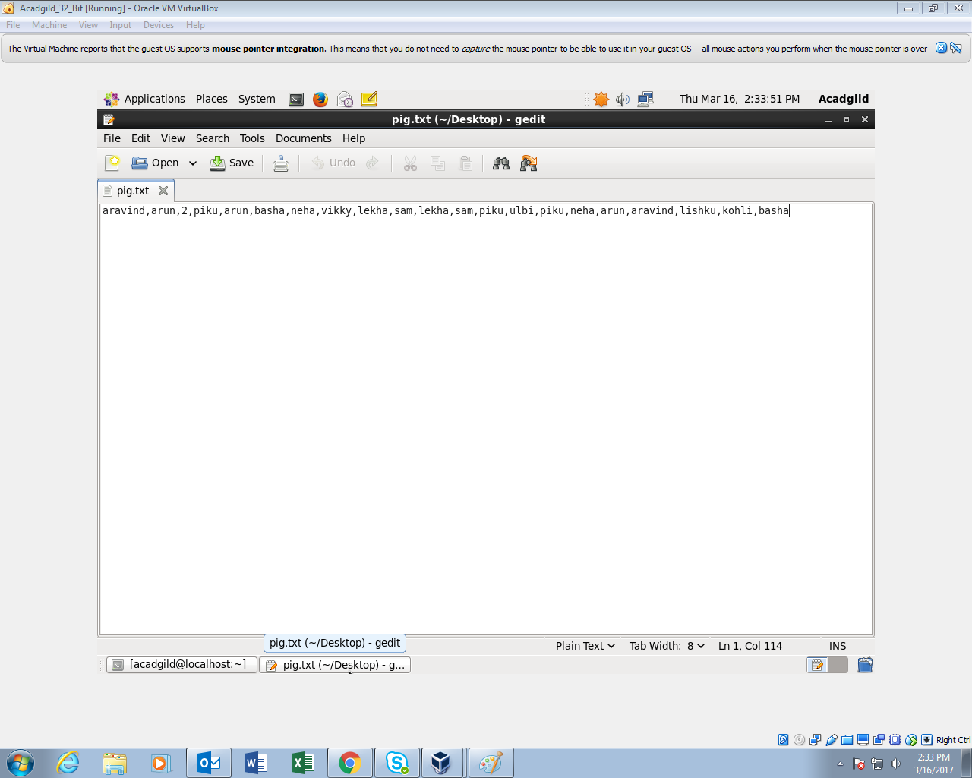

COMMANDS USED:

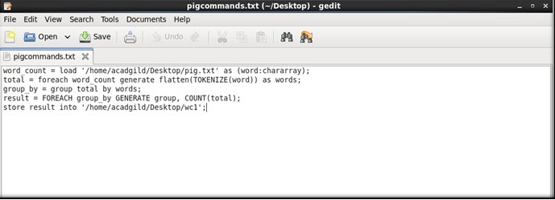

* LOAD COMMAND : The File for which the word count has to be performed is fed into the pig shell with the help of this command.
* FLATTEN COMMAND : Used to convert bag in to tuples.
* GROUP BY COMMAND : Used to group similar words
* COUNT COMMAND : Used to count the grouped words
* STORE COMMAND : Used to store the processed o/p as a text file.

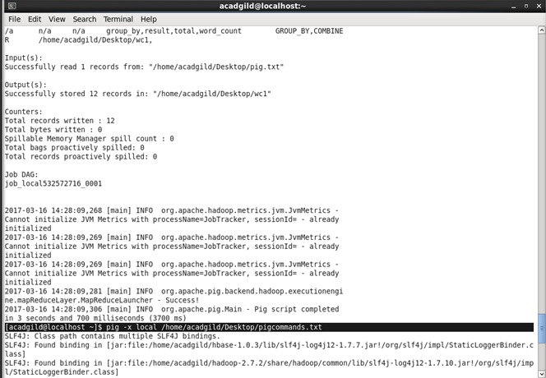

OUTPUT FILE :